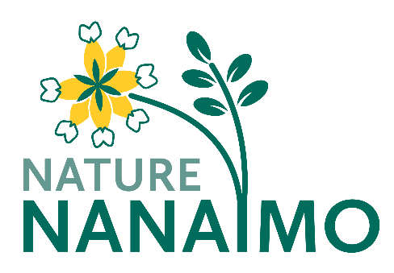
Nature Nanaimo 2020-2021 President’s Report
The past year continued to be an unusual time for Nature Nanaimo. The ongoing pandemic resulted in general meetings continuing to be presented by zoom through the winter and spring and we had a significantly reduced number of “in-person” outings. At the same time, given the circumstances, our membership has proven resilient and we had many worthwhile and engaging presentations and some excellent outdoor events. As of September, there was at least a hint of normality returning and we have hosted optional in-person monthly meetings at Beban Park while offering them simultaneously via zoom.
We were able to provide fascinating and informative presentations on local bird banding efforts by Eric Demers, the relationships between moose populations and forestry with Roy Rea, the spring flora of the Nanaimo region with Caroline Josefsson, and efforts to keep BC Gypsy moth free with Tim Ebata and Jennifer Heron. We also took advantage of zoom with Staffan Lindgren offering zoom sessions on using iNaturalist and eBird. Prior to our summer break we also had a June zoom meeting where we obtained input from members on interests and future activities. In September our first in-person meeting featured a talk on Western Screech Owls with Tania Tripp and in October, I gave a presentation on the Galapagos Islands.
When covid protocols allowed, we were able to share our love of nature with a number of outings that included explorations of the intertidal zone during some very low tides, a ramble in Paradise Meadows, Strathcona Park, and a mushroom hunt led by expert Terry Taylor. We enjoyed a return to our “June Picnic” event with a wonderful gathering on Saysutshun Island. Members also pitched in on a number of occasions to clear some invasive species at Buttertubs Marsh.
In addition to our meetings and outings, 2021 saw Nature Nanaimo connecting with other organizations including WE-CAN (Western Canada Climate Action Network) and the NCAH (Nanaimo Climate Action Hub) to help support and share information on efforts to address climate change. As noted in the Executive Secretary’s report, we have continued our involvement with Buttertubs marsh - reaching out to the Nature Trust of BC and City staff and hope to ramp up activities once things return to normal.
This year also saw the launching of our wonderful Nature Nanaimo Newsletter as a way to better share and highlight upcoming events and a wide variety of nature related information. A major thank you goes to Lindsay Dealy for her efforts and expertise in making this happen!
I look forward to the year ahead which I hope and suspect will be a little more predictable and routine with more in-person gatherings and outings while providing members with many opportunities to enjoy the natural beauty of Vancouver Island and beyond.
Lasty, I wish to thank each of our board members for their ongoing efforts!
Sincerely, Doug Fraser
President
Nature Nanaimo

